Civic Sense Management System
1. Introduction
The Civic Sense Management System is a Python-based application that enables citizens to report civic issues such as garbage dumping, potholes, water leakage, streetlight failures, illegal parking, public cleanliness, and damaged roads. The system stores complaints, assigns priorities, analyzes issue data, and helps administrators manage civic problems efficiently.
This project is designed according to the four development phases specified in the course syllabus and demonstrates practical applications of data structures and algorithms.
2. Problem Statement
Many civic complaints are handled manually, leading to delays in response and poor tracking. Citizens often cannot monitor the progress of their complaints, while municipal authorities struggle to prioritize and manage issues effectively.
The proposed system provides an organized digital platform for complaint submission, tracking, prioritization, and analysis using Python data structures and algorithms.
3. Objectives
- Digitize civic complaint management.
- Allow citizens to report public issues.
- Prioritize complaints automatically.
- Reduce manual work.
- Demonstrate implementation of data structures.
- Apply searching and sorting algorithms.
- Use optimization algorithms for complaint handling.
4. Scope
The system includes:
- Citizen Registration
- Complaint Submission
- Complaint Tracking
- Complaint Prioritization
- Complaint Search
- Complaint Sorting
- Area-wise Analysis
- Admin Dashboard
- Reports
- Statistics
5. Technologies
Component | Technology
Language | Python
GUI | Tkinter
Database | Mysql
Charts | Matplotlib
Images | Pillow
CSV Report | Pandas

6. Modules
1. 👤 Citizen Panel
Manage Profile
- View profile
- Edit profile
- Change password
Manage Complaints
- Submit new complaint
- View submitted complaints
- Edit complaint
- Delete complaint
- Upload complaint image
- Select complaint category
- Enter location
Track Complaint
- View complaint status
- View assigned department
- View status history
- View resolution details

Search Complaints
- Search by complaint ID
- Search by category
- Search by location
- Search by status
Feedback & Rating
- Give rating
- Submit feedback
- View previous feedback

2. 🛠️ Admin Panel
Dashboard
- Total users
- Total complaints
- Pending complaints
- In-progress complaints
- Resolved complaints
- High-priority complaints
- Complaint statistics
Manage Users
- View users
- Add user
- Edit user
- Delete/block user
- Search users
- View user complaint history
Manage Complaints
- View all complaints
- View complaint details
- Approve/reject complaint
- Update complaint status
- Delete complaint
- Assign complaint
- Add admin remarks
Manage Categories
- Add category
- Edit category
- Delete category
- View categories
Example:
- Garbage
- Pothole
- Water Leakage
- Streetlight
- Drainage
- Illegal Parking
Manage Priorities
- Set priority
- Change priority
- View high-priority complaints
- Manage emergency complaints
Priority:
High → Medium → Low
Manage Departments
- Add department
- Edit department
- Delete department
- Assign department to complaint
Example:
- Sanitation Department
- Water Department
- Road Department
- Electricity Department
- Traffic Department
Manage Locations
- Add area
- Edit area
- Delete area
- View area-wise complaints
Manage Feedback
- View citizen feedback
- View ratings
- Respond to feedback
Reports & Analytics
- Complaint report
- User report
- Category-wise report
- Area-wise report
- Monthly report
- Resolution report
- Priority report
Admin Settings
- Admin profile
- Change password
- System settings
- Logout

3. 🏢 Department Panel
This panel is useful if you want the project to look more like a real municipal system.
Dashboard
- Assigned complaints
- Pending complaints
- In-progress complaints
- Resolved complaints
Manage Assigned Complaints
- View assigned complaints
- Accept complaint
- Start work
- Update status
- Mark as resolved
Manage Workers
- Add workers
- Edit workers
- Remove workers
- Assign workers to complaints
Complaint Processing
- View complaint location
- View complaint priority
- Add work remarks
- Upload resolution image
Reports
- Completed complaints
- Pending complaints
- Department performance
- Worker performance

4. 🚨 Emergency/Priority Management Module
This can be a separate feature or part of the Admin Panel.
Manage High-Priority Complaints
- Identify critical complaints
- Assign priority
- Process emergency complaints first
- Monitor critical complaints

Priority Queue
High Priority
↓
Medium Priority
↓
Low Priority
DSA: Heap / Priority Queue

5. 🗺️ Area & Location Management
Manage Areas
- Add area
- Edit area
- Delete area
- View areas
Area-wise Complaints
- View complaints by area
- Find problem-prone areas
- Count complaints per area
Area Connectivity
Represent connected areas using a Graph.
Area A ─── Area B
│ │
│ │
Area C ─── Area D
DSA: Graph
Algorithms: BFS / DFS

6. 🔎 Search & Sort Module
Search
- Search complaint by ID
- Search by citizen
- Search by category
- Search by location
- Search by status
Algorithms
- Linear Search
- Binary Search
Sorting
- Sort by priority
- Sort by date
- Sort by complaint ID
- Sort by category
- Sort by status
Algorithms
- Insertion Sort
- Merge Sort
- Quick Sort

7. 📊 Data Analysis & Reports Module
Complaint Analysis
- Total complaints
- Pending complaints
- Resolved complaints
- Rejected complaints
Category Analysis
- Garbage complaints
- Road complaints
- Water complaints
- Electricity complaints
Area Analysis
- Most problematic area
- Least problematic area
- Area-wise complaint count
Time Analysis
- Daily complaints
- Weekly complaints
- Monthly complaints
Visualization
- Bar Chart
- Pie Chart
- Line Chart

8. 🧠 Algorithm & DSA Module
This module connects your actual application with your 4 course phases.
Linear Data Structures
- Linked List → Store/process complaints
- Queue → Complaint processing
- Stack → Complaint action history/undo
Tree
- Binary Tree
- Binary Search Tree
- Tree Traversals
Graph
- City/area representation
- BFS
- DFS
Searching
- Linear Search
- Binary Search
Sorting
- Insertion Sort
- Merge Sort / Quick Sort

Priority Processing
- Heap
- Priority Queue
Optimization
- Greedy Algorithm
- Dynamic Programming or
- Backtracking

9. 🔔 Notification Module
Citizen Notifications
Notify users when:
- Complaint submitted
- Complaint approved
- Complaint assigned
- Complaint is in progress
- Complaint resolved
- Complaint rejected
For a Python academic project, these can initially be in-app notifications.

10. ⭐ Feedback & Rating Module
Citizen
- Rate complaint resolution
- Give feedback
- Add remarks
Admin
- View ratings
- View feedback
- Analyze citizen satisfaction

Project Phases:
Phase 1 – Core Data Handling using Linear Structures (CLO1)
Requirements from syllabus
Requirement | Civic Sense Application
Dataset | Civic complaint records
Linked List | Complaint history
Stack | Undo complaint status/actions
Queue | Complaint processing
Infix → Postfix | Complaint/filter expression handling
Iterative | Dataset/linked-list traversal
Recursive | List/tree traversal

Implementation in Civic Sense Project
Dataset Input
- Complaint records
- Citizen records
- Admin record
complaint_id | citizen_id | category | location | priority | status | description
101 | 1 | Garbage | Area A | High | Pending | Garbage dumped near road
102 | 2 | Pothole | Area B | Medium | Assigned | Large pothole on main road
103 | 3 | Streetlight | Area C | Low | Resolved | Streetlight not working
104 | 4 | Water Leakage | Area A | High | Pending | Water pipe leakage

Linked List
Store complaint records dynamically.
Example:
Complaint 101
↓
Complaint 102
↓
Complaint 103
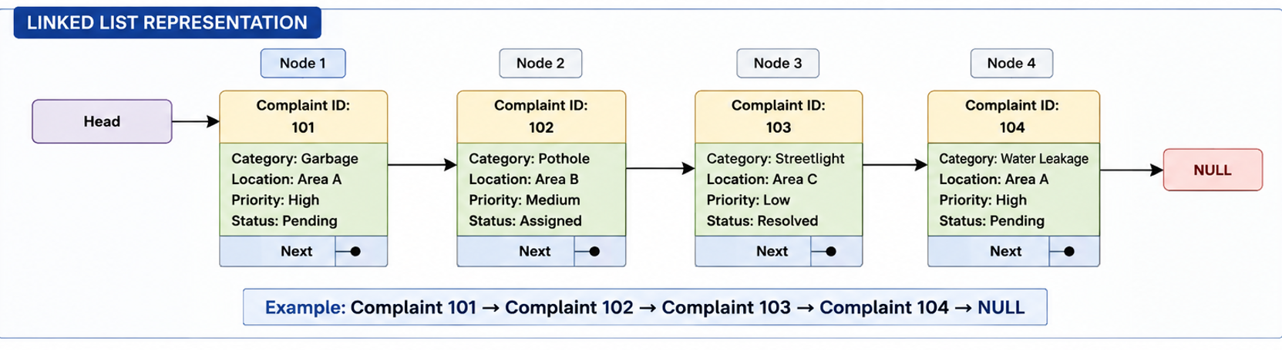
Operations
- Insert complaint
- Delete complaint
- Search complaint
- Update complaint
- Traverse complaints

Queue
Complaint Processing
Citizen 1
↓
Citizen 2
↓
Citizen 3
First complaint submitted is processed first.

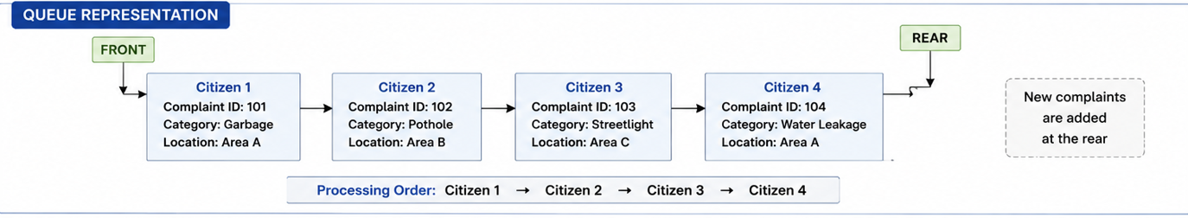
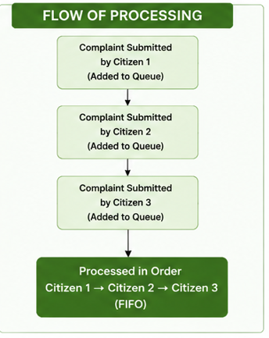

Stack
Undo Recent Complaint Update
Latest Action
↓
Previous Action
↓
Older Action

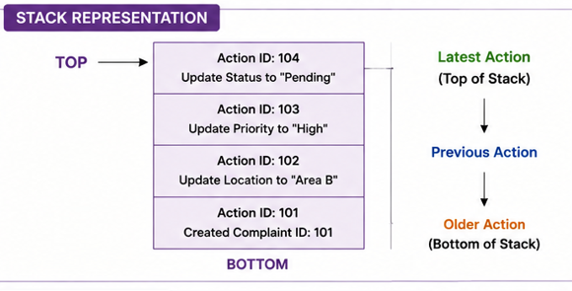

Expression Handling
Basic expression validation for complaint filters or search expressions (optional bonus feature)

Phase 2 – Structured Data Representation (CLO2)
Binary Tree
Store complaint IDs.
50
/ \
30 80

Binary Search Tree
Search complaint quickly.
Search Complaint ID

Graph
Represent city map.
Area A ---- Area B
| |
Area C ---- Area D

BFS
Find nearby complaint locations.
DFS
Traverse connected city areas.

Phase 3 – Searching and Sorting (CLO3)
Linear Search
Search
- Complaint ID
- Citizen Name

Binary Search
Search sorted complaint IDs.

Sorting
Implement
- Merge Sort
- Quick Sort
Sort complaints by
- Priority
- Date
- Area
- Status

Heap (Priority Queue)
Priority Processing
High Priority
↓
Medium
↓
Low
Emergency complaints appear first.

Phase 4 – Basic Algorithmic Optimization (CLO2)
Choose one optimization technique from the syllabus.

Recommended: Greedy Algorithm
Assign municipal workers to the highest-priority complaints first.
Example:
Complaint | Priority
Water Leakage | High
Garbage | Medium
Street Light | Low

- Expected Outcomes
- Provide an easy way for citizens to report civic problems.
- Maintain complaints in a structured manner.
- Help administrators identify high-priority issues.
- Reduce the time required to process complaints.
- Provide efficient complaint searching and sorting.
- Track complaints from submission to resolution.
- Identify areas with frequent civic problems.
- Generate useful reports and statistics.
- Demonstrate practical implementation of linear structures, trees, graphs, searching, sorting, heaps, and optimization algorithms.
- Provide a strong real-world Python project suitable for academic demonstration.

